**User manual for Digiplan**

* **Steps for registering a new Doctor with 32 Watts.**

1. Firstly user have to open the 32 Watts website i.e. [www.32watts.com](http://www.32watts.com).
2. Then user have to click on login button.



1. A new html page will be loaded when user click on the login button. Now user have to enter the valid login credentials.

The login credentials are:

Username: panchalg

Password: render123#

1. After login a new screen appears. User have to click on add doctor present at top right corner.

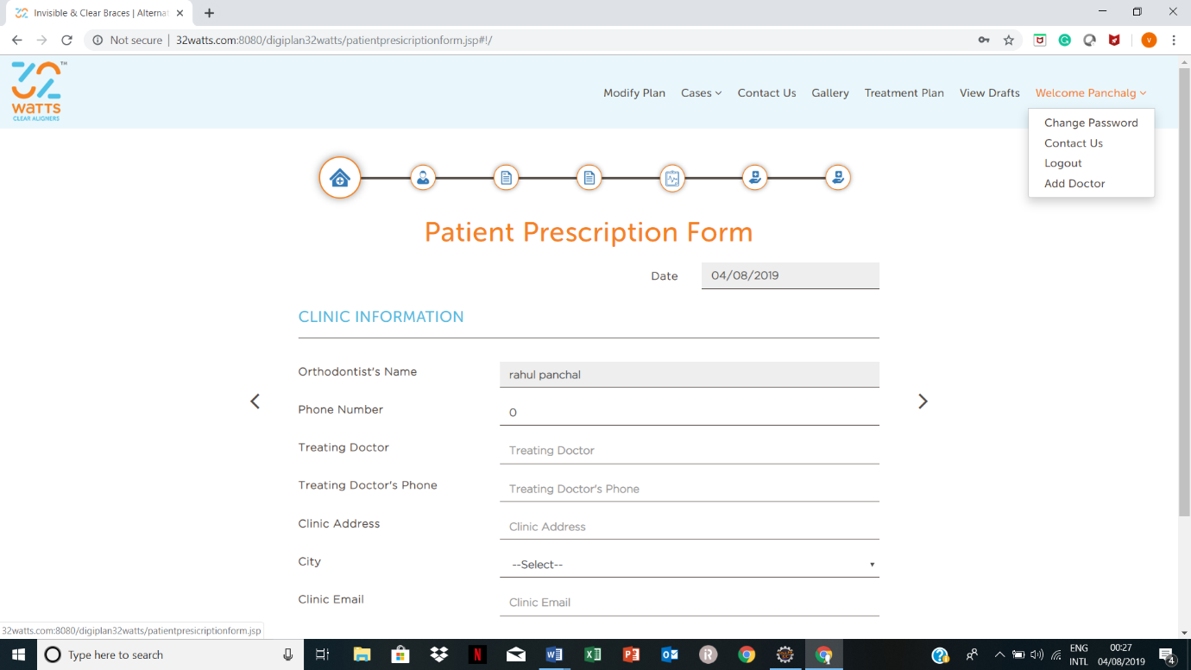

1. Now user have fill the appropriate entries. The doctor id is filled according to rules and regulations of company. Suppose doctor name is Varun Grover. Then the doctor id will drvgrover. Usually this pattern is followed. After filling entries user have to click on submit button. The doctor is registered with the company. After that user can logout.

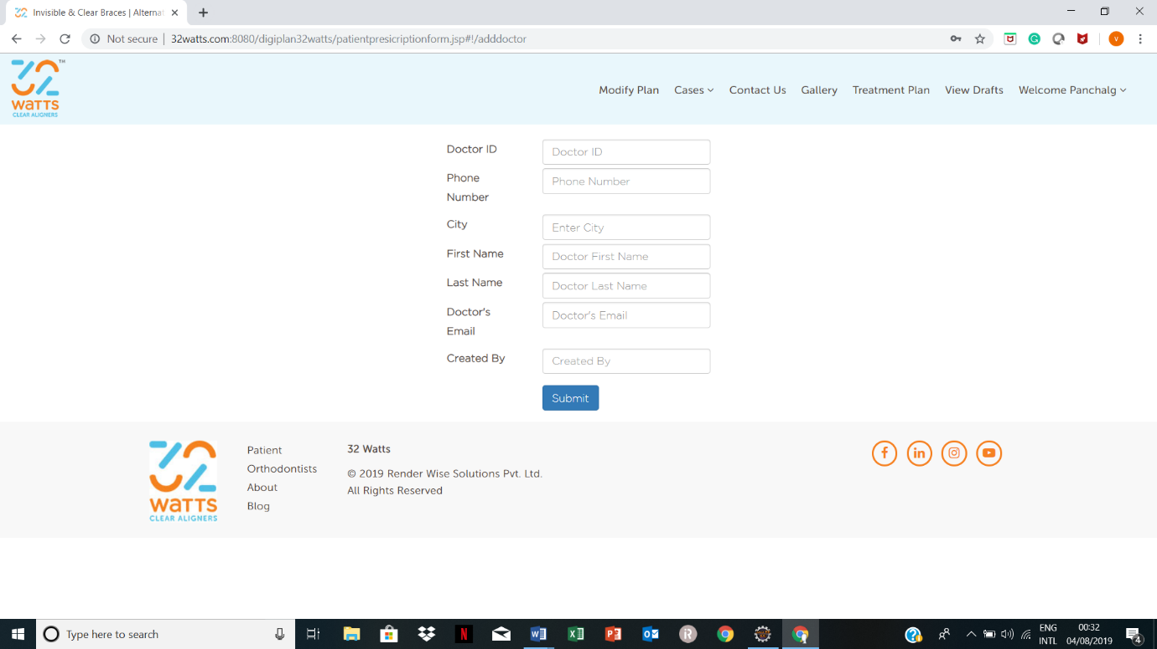

* **Steps for creating new case- id of patient**

1. Firstly user have to open the 32 Watts website i.e. [www.32watts.com](http://www.32watts.com).
2. Then user have to click on login button.



1. A new html page will be loaded when user click on the login button. Now user have to enter the valid login credentials.

The login credentials are:

Username: panchal1

Password: 12345

1. After login a new screen appears. User have to click on view incomplete present at top centre of screen.

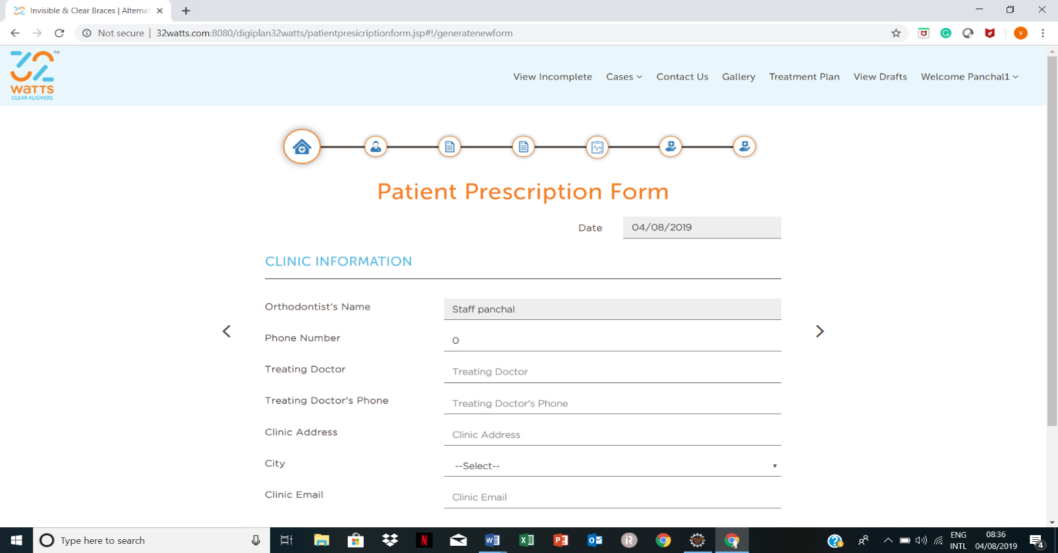

1. Whenever a new prescription form is filled by doctor, automatically form id and all other details will be shown on screen. Now user task is to generate case id according to rules and regulations of company. User have to click on create case button.

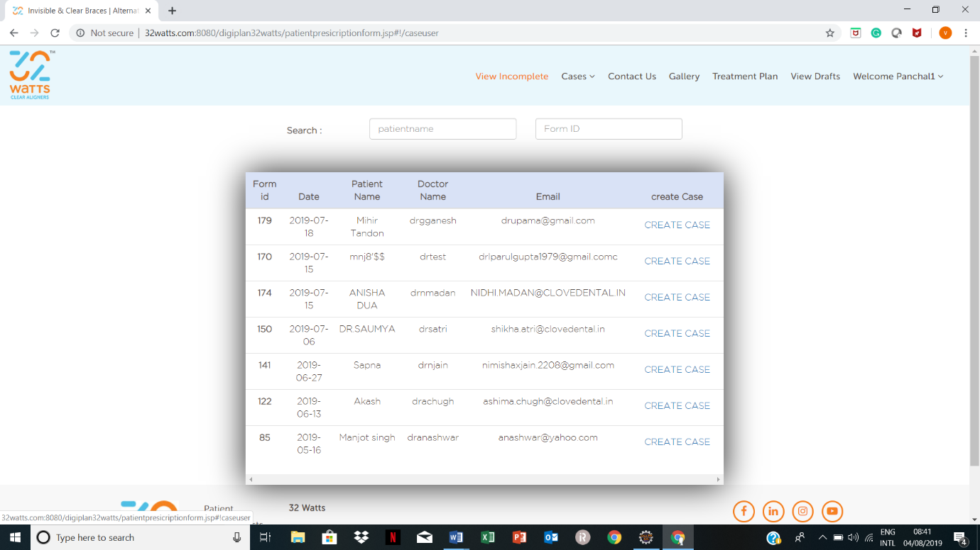

1. When user click on create case a new screen appears. Fill the appropriate case id and click on submit. Case-id is generated.

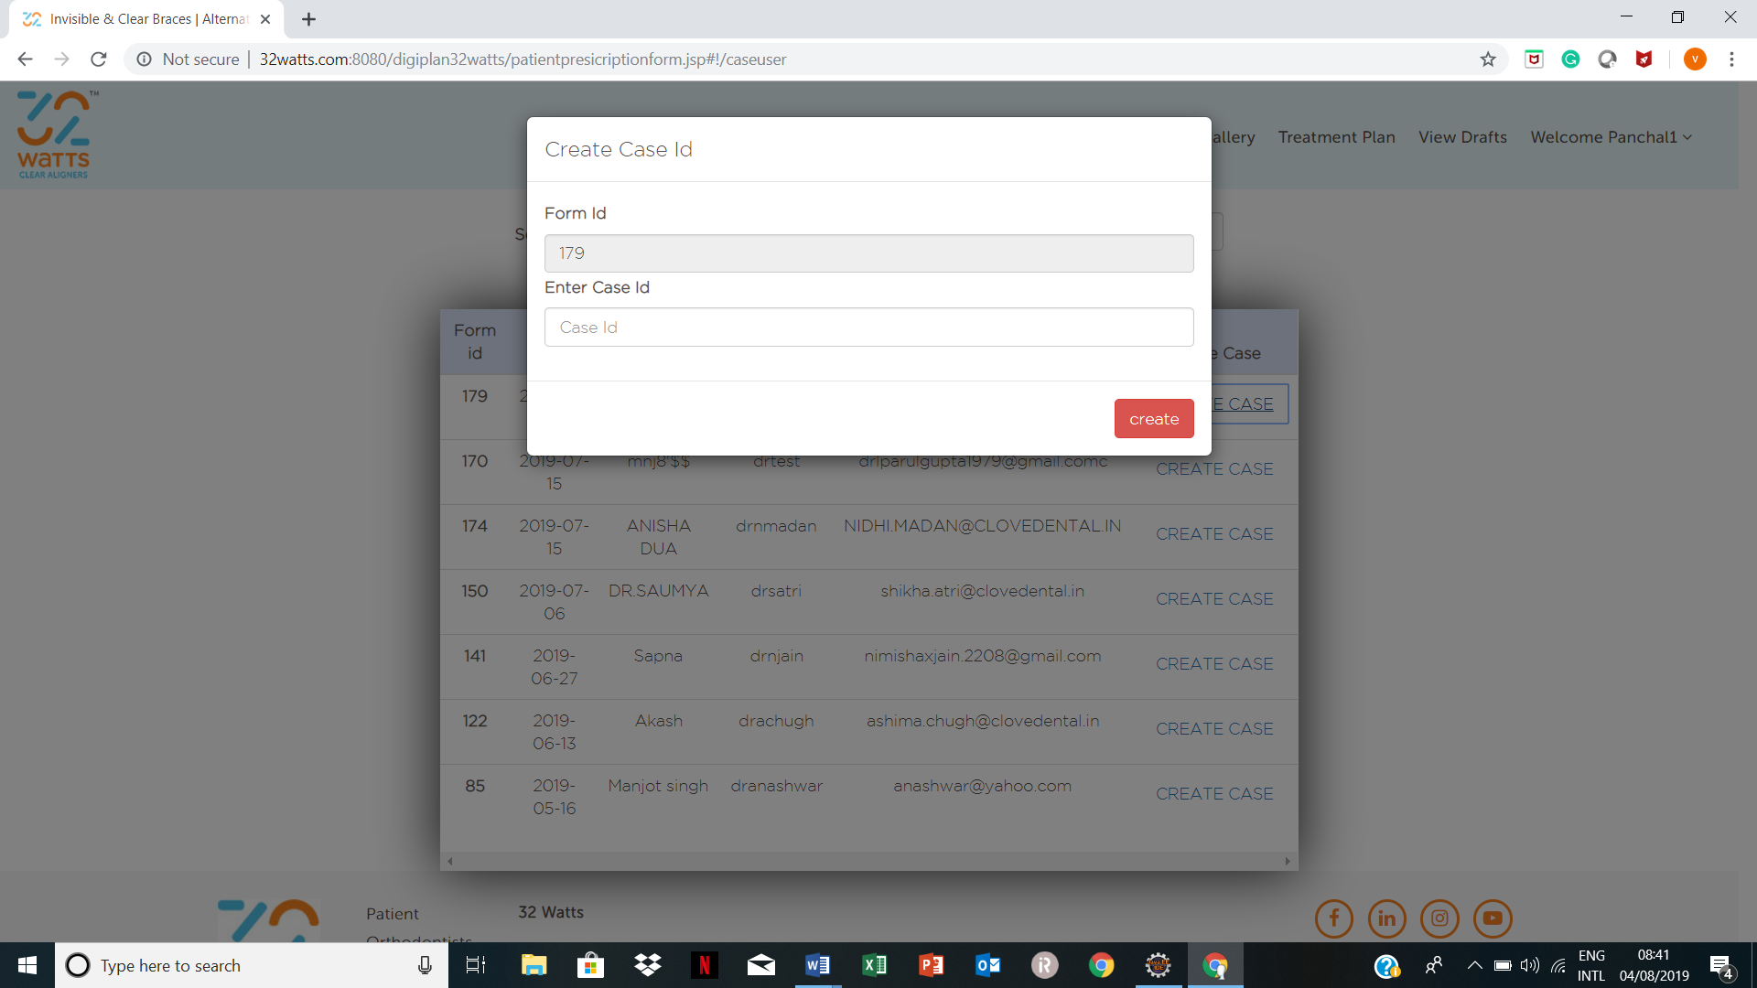

* **Steps for modifying the plan no. and case-id**

1. Firstly user have to open the 32 Watts website i.e. [www.32watts.com](http://www.32watts.com).
2. Then user have to click on login button.



1. A new html page will be loaded when user click on the login button. Now user have to enter the valid login credentials.

The login credentials are:

Username: panchalg

Password: render123#

1. After login a new screen appears. User have to click on modify plan.



1. Now user have fill the appropriate entry. The modified case id and plan no is filled according to rules and regulations of company.

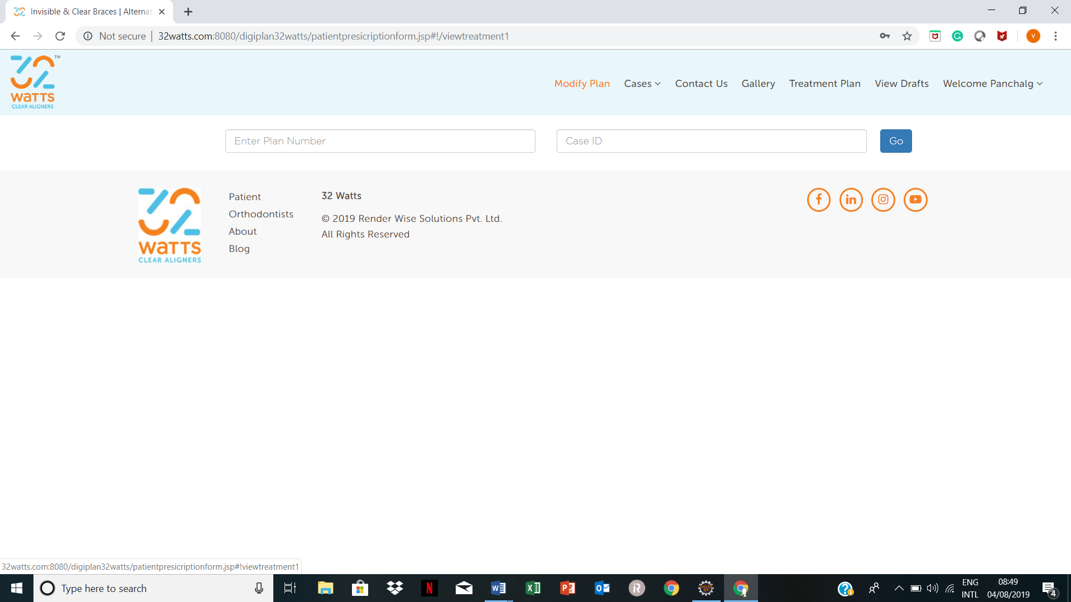

1. After filling entries user have to click on go button to modify case-id.

* **Steps for extracting the photos which are uploaded by doctor in prescription form:**

1. Firstly, user have open any FTP tool. Here we are using WinSCP tool. User can find WinSCP tool in search bar or find on desktop.
2. A new screen appears. User have to fill valid hostname, port no., username and password.

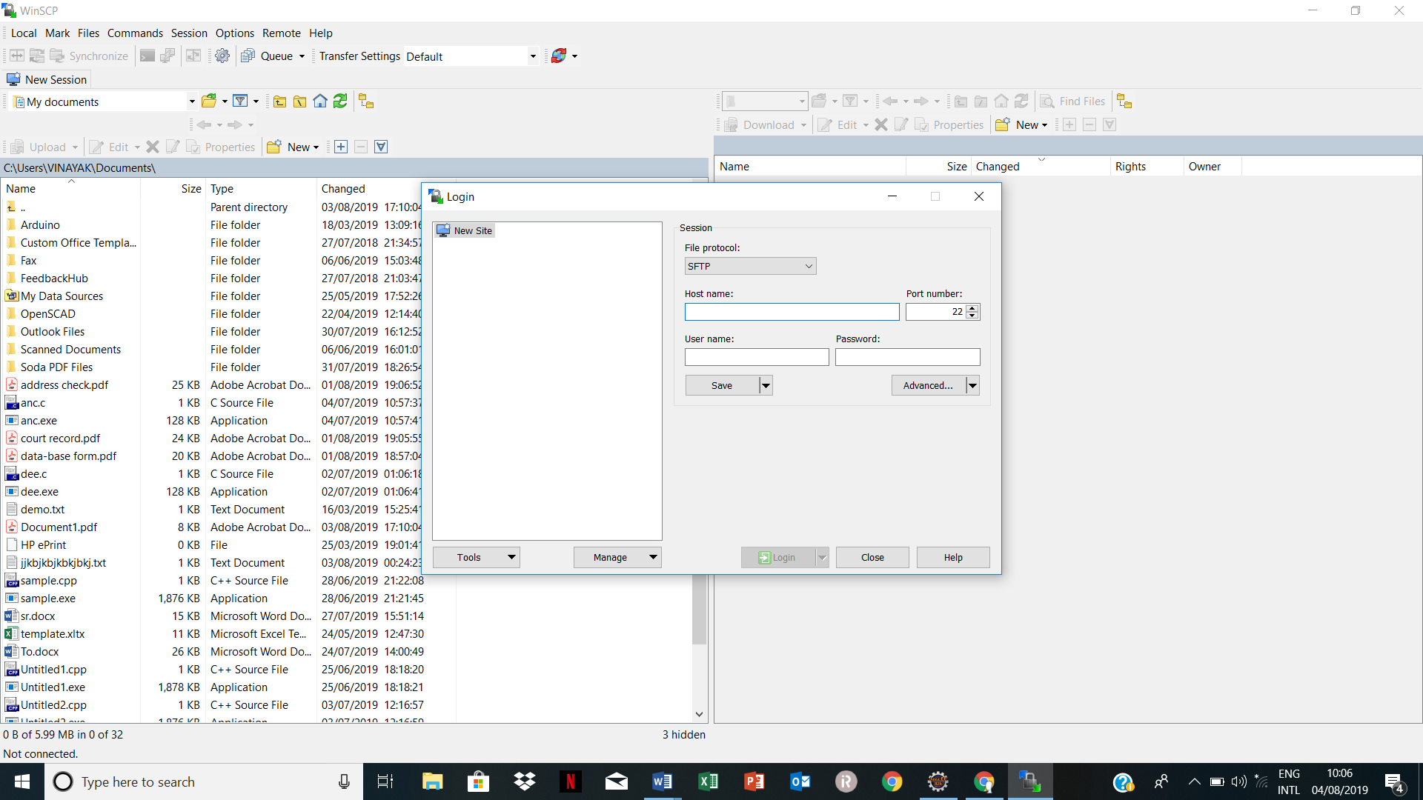

1. Now user have to open uploads folder. /<root>🡪software🡪Tomcat🡪apache-tomcat-8.0.47🡪webapps🡪digiplan32watts🡪uploads.

User can drag and drop the particular folder which he wants from server to his local computer.

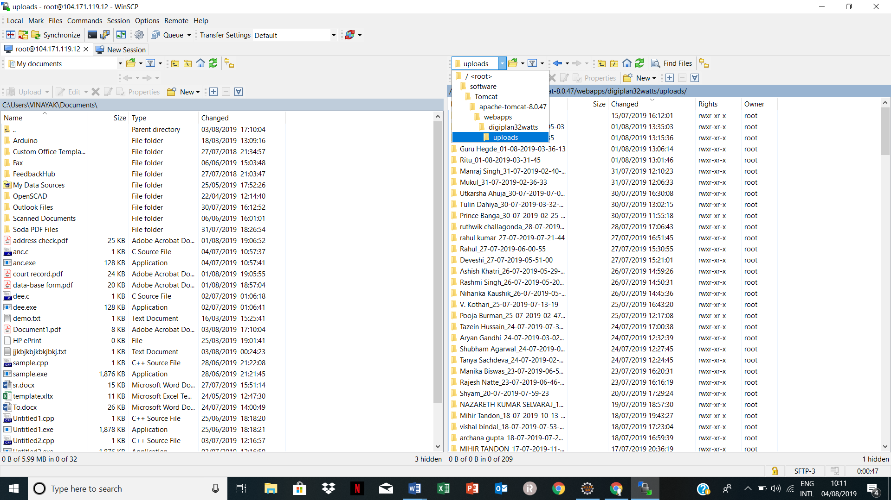

* **Steps for adding a case into another’s doctor id.**

1. Firstly open the cpanel. You can get the login credentials and hostname from director’s room. After login click on the phpMyAdmin.

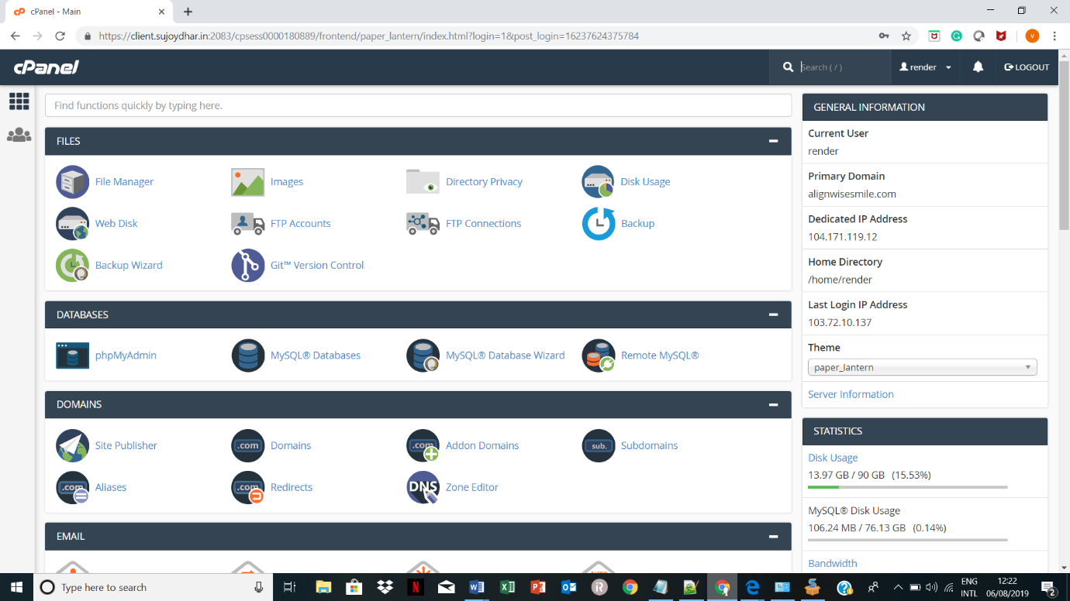

1. Open the render_digiplan database. In render_digiplan open alignwise_cases table. Then click on the SQL the execute an entry.

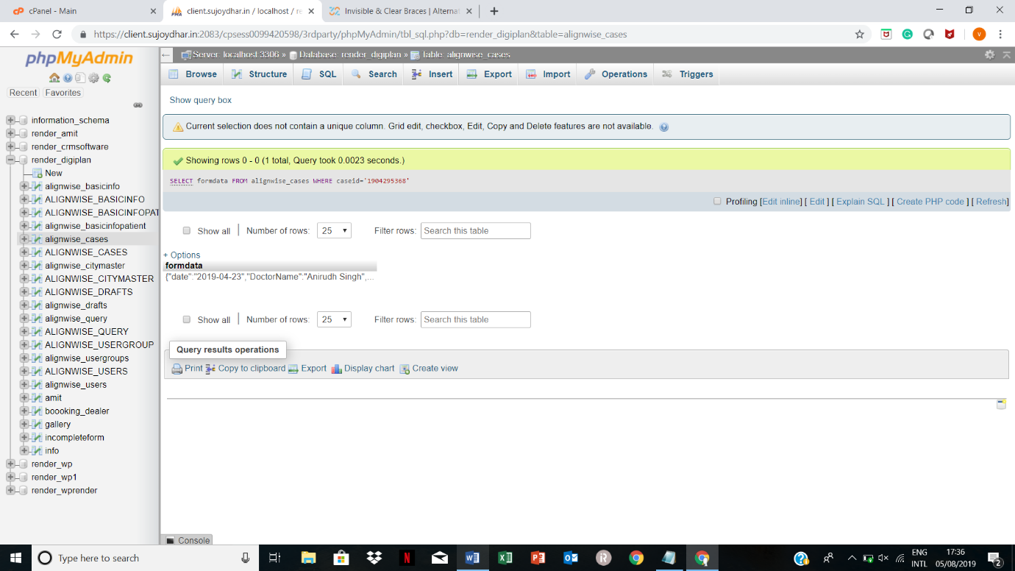

1. SELECT * FROM alignwise_cases WHERE caseid='1904295368';

Execute this query to check whether the case exists or not. The case-id which we want to chech is added to to single quote.

1. You must have doctor username , first name info in which you want to add case.
2. SELECT formdata FROM alignwise_cases WHERE caseid='1904295368';

Execute this query to download the form data. Export the form data in csv for excel format.

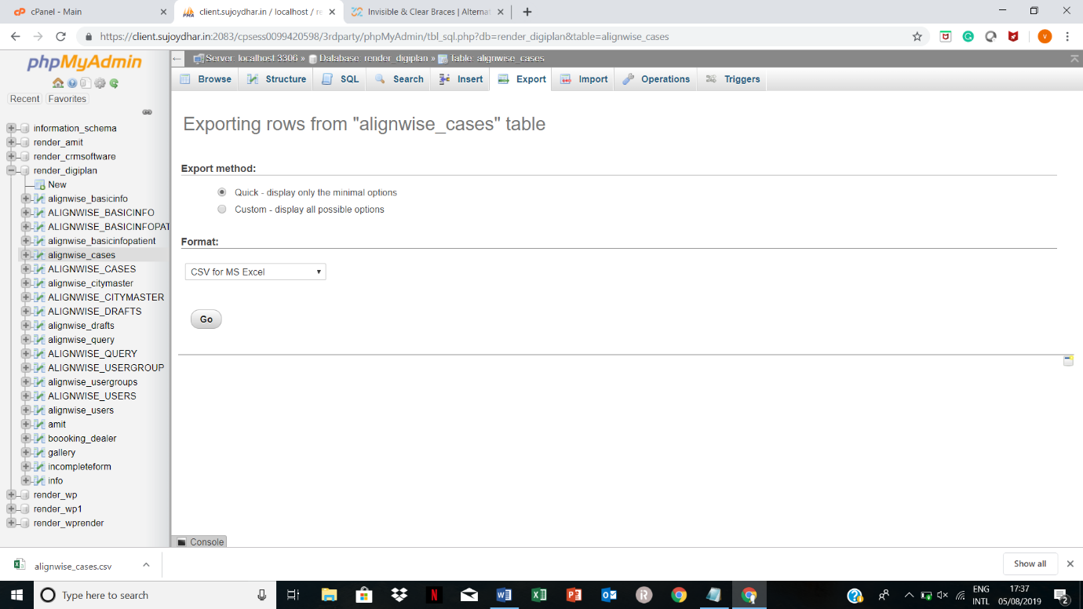

1. Once you download the form data, replace the username, first name and last name with your desired credentials.

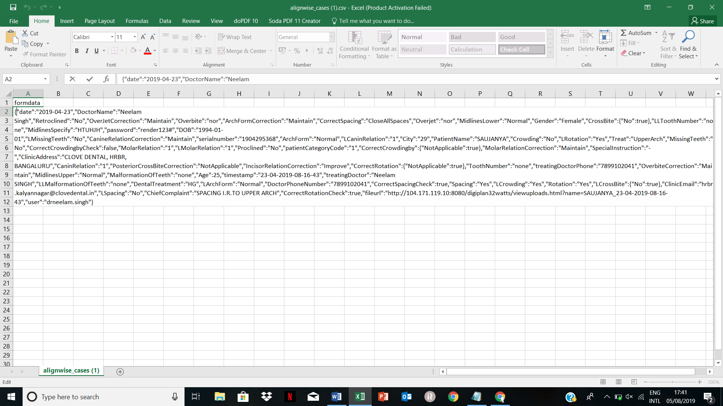

1. Once you are done with it, again open the SQL and execute the query.

INSERT INTO alignwise_cases (caseid, formdata, remarks)

VALUES (' ', ' ', 'new case added');

In first single quote you have to add case id and in second the complete form data which you have changed with username. Now execute the query.

The case will reflect in doctor’s id.

* **Steps for checking the password of our registered doctor.**

1. Firstly open the cpanel. You can get the login credentials and hostname from director’s room. After login click on the phpMyAdmin.



1. Open the render_digiplan database. In render_digiplan open alignwise_users table. Then click on the SQL the execute an entry.



1. SELECT * FROM alignwise_users WHERE username='drneelam.singh';

Execute this query to check all the details of doctors.

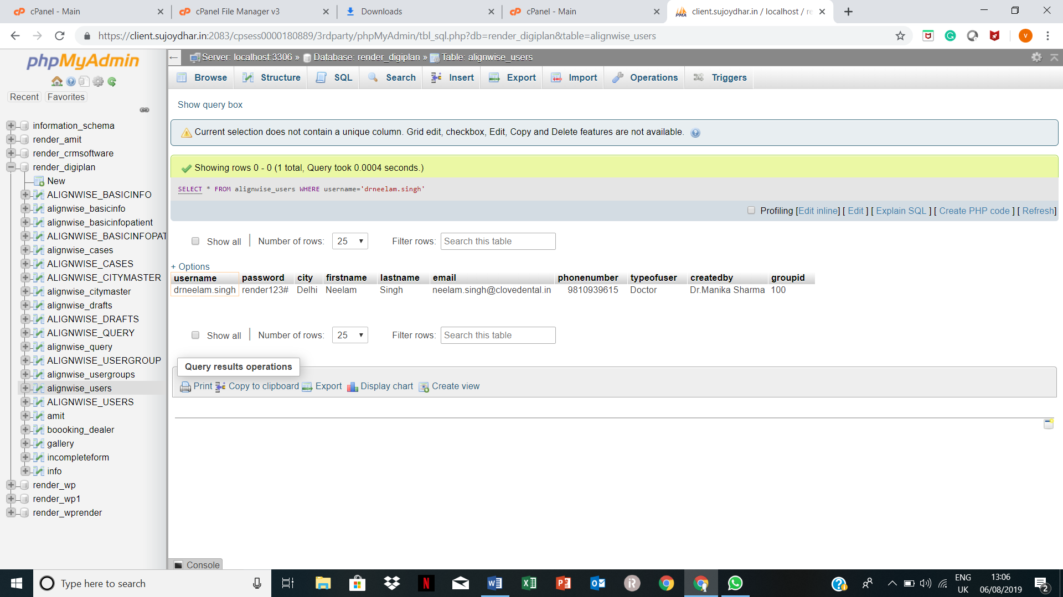

1. So all the details are present of a particular doctor.
2. So all the details of doctor are present.